**Intern Report**

***1st July, 2017***

**Project 1:** Practice Application

Installation

Hello World App

CRUD Operation

Screen Design

Database Connectivity

**My role:**

Entire application executed over local network.

**Project 2:** Expense Tracker Application

**Level 1:** UCD, ER Diagrams, DB Schema, Class Diagram

**My role:**

Formulated the final User Case Diagram (Image below)

[Status: Approved]

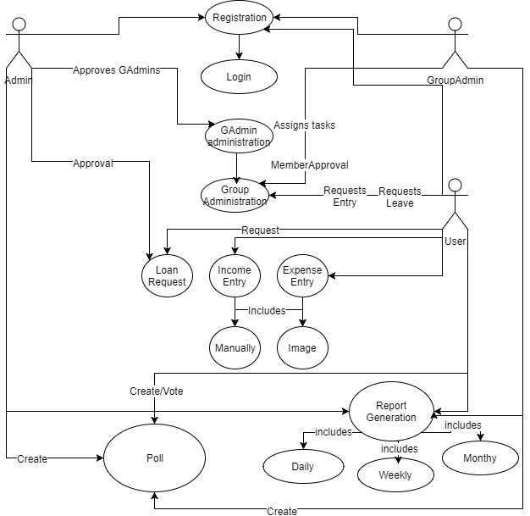

**Level 2:** Screen development

**My role:**

Chose to handle registration module (Images below)

Screens developed via HTML, CSS and JavaScript

Figure 1: Registration page/Home

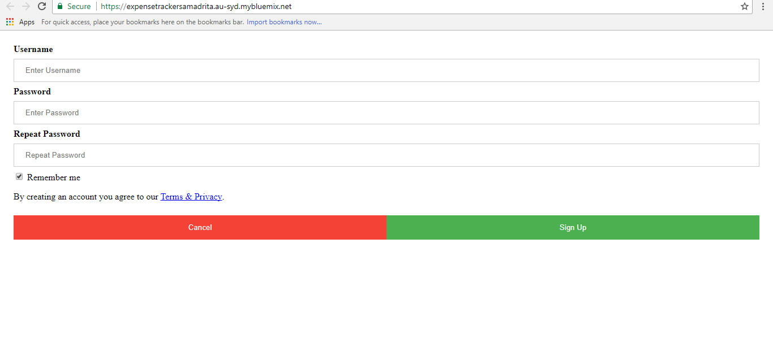

Figure 2: After Sign Up

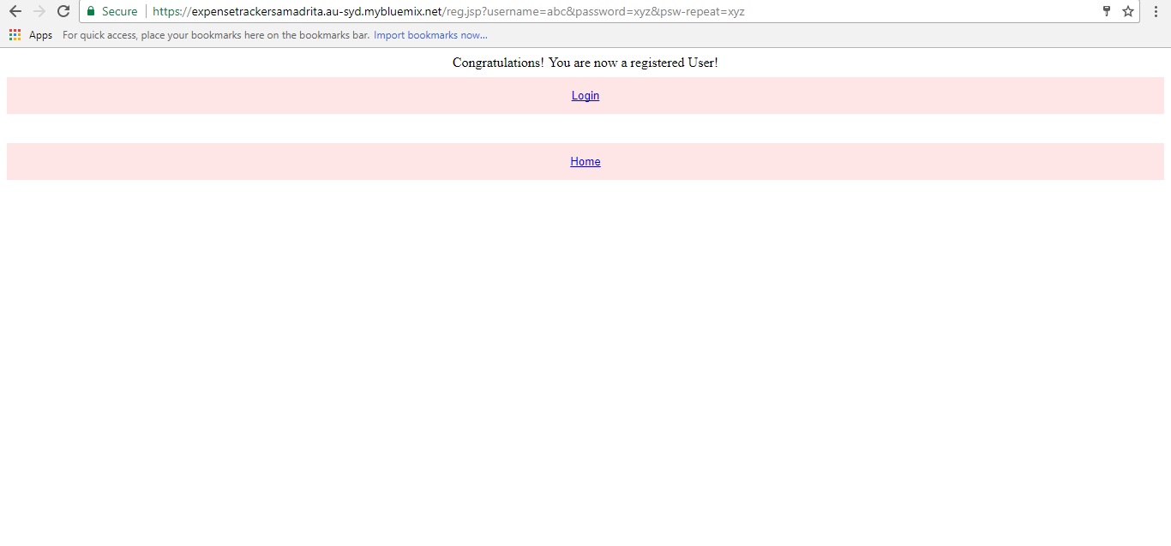

Figure 3: Login Page (to cross check)

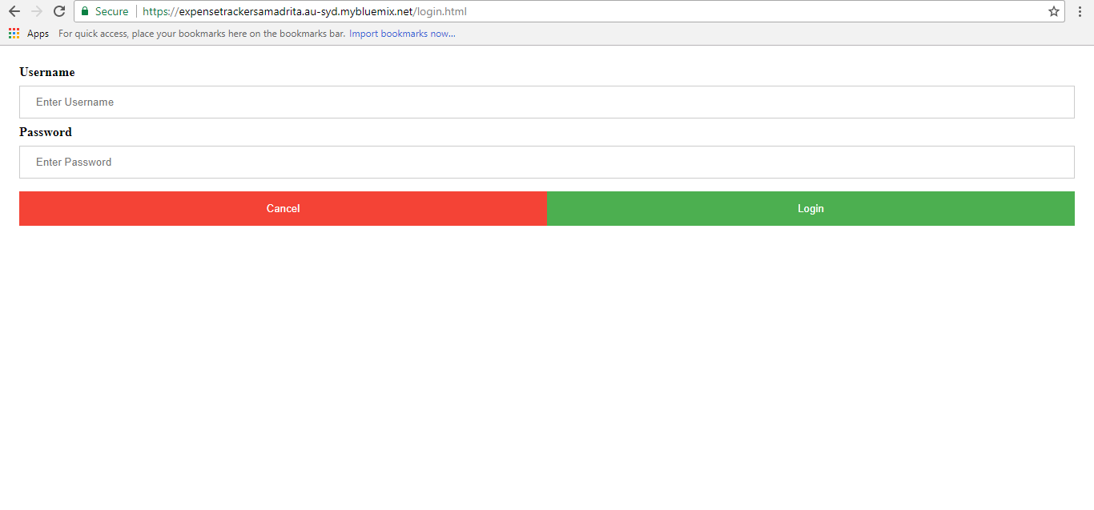

**Level 3:** Design of Class modules and connection to screens

**My role:**

Designed the following (links provided):

[login.jsp](https://github.com/samadrita1/expensetracker/blob/master/login.jsp)

[reg.jsp](https://github.com/samadrita1/expensetracker/blob/master/reg.jsp)

[index.html](https://github.com/samadrita1/expensetracker/blob/master/index.html)

[login.html](https://github.com/samadrita1/expensetracker/blob/master/login.html)

Additionally developed:

[createBill.java](https://github.com/samadrita1/expensetracker/blob/master/createBill.java)

[deleteBill.java](https://github.com/samadrita1/expensetracker/blob/master/deleteBill.java)

**Level 4:** Creating Database Schema through MySQL

**My role:**

Created the following table for registration and login modules



Linked to source code via mysql-connector (JDBC)

**Level 5:** Cloud Deployment

**My role:**

Accessed Bluemix Cloud (IBM)

Installed Bluemix tools in Eclipse Neon

Connected online database to MySQL

Reflected credentials (username, password and DB link) in the source code

Dropped application in Bluemix server to deploy

Final link: <https://expensetrackersamadrita.au-syd.mybluemix.net/>

**Project 3:** Zonal Desk

**Level 1:** UCD, ER Diagrams, DB Schema, Class Diagram

**My role:**

Formulated the User Case Diagram (Image below)

[Status: Not approved]

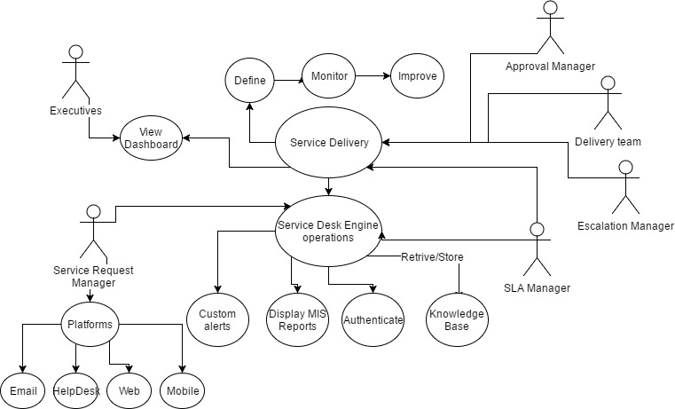

Member of Team A, which formulated the final ER diagram.

[End of Interning term]

***Reporting:***

***Samadrita Ghosh***

***KIIT University/Biztime IT Intern 17’***